Service Components

-Day Supports (Individual & Group) – Day Supports is primarily a group service that provides assistance to the individual with acquisition, retention, or improvement in self-help, socialization and adaptive skills. Day Supports are furnished in a non-residential setting, separate from the home or facility where the individual resides. Day Supports focus on enabling the individual to attain or maintain his or her maximum functional level and is coordinated with any physical, occupational, or speech therapies listed in the Individual Support Plan. Transportation to/from the individual’s home, the day supports facility and travel within the community is included.

Individual Supports - Individual Support is a “hands-on” service for persons with Serious and Persistent Mental Illness (SPMI). The intent of the service is to teach and assist individuals in carrying out Instrumental Activities of Daily Living (IADLs), such as preparing meals, managing medicines, grocery shopping and managing money, so they can live independently in the community. The goal is that the need for this service will fade or decrease over time as the individual becomes capable of performing some of these activities more independently.

Respite - Respite services provide periodic support and relief to the primary caregiver(s) from the responsibility and stress of caring for the beneficiary. This service enables the primary caregiver to meet or participate in planned or emergency events, and to have planned time for him/her and/or family members.

What Makes Quality Care Solutions Inc. Different?
Contact Information

Corporate Office
3824 Barrett Drive; Suite 105
Raleigh NC 27609
(919) 790-7775 office
(919) 790-9755 fax

Rocky Mount Office
301 S. Church St.
Suite 163
Rocky Mount, NC 27804
252-977-2200 office
252-977-2220 fax

CARF AND CABHA ACCREDITED

www.qcsolutions.org

Quality Care Solutions Inc. utilizes a holistic approach to mental health and intellectual/developmental disability services. Our services go far beyond the scope of traditional day supports and innovations services. This approach is used to optimize the potential for positive and permanent change

Our goal is to instill fundamental morals and values which will assist with laying the ground work for short term and long term success. Our consumers learn independent living skills in a real environment. Our facility features a mock bedroom with a bed and washer/dryer. We also have a computer lab, fitness center, and mock grocery store.

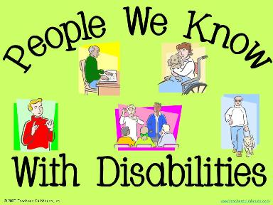
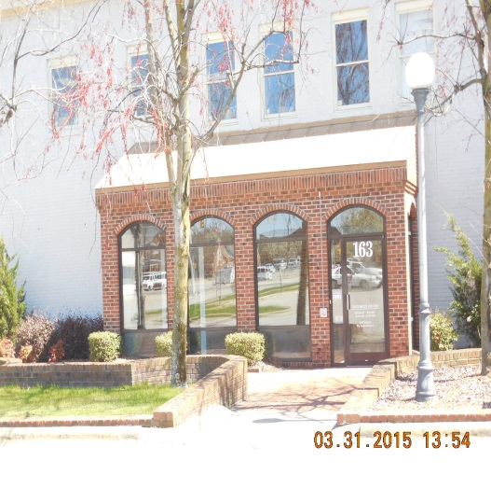
“A Holistic Approach to I/DD services”
301 S. Church St.
Suite 163
Rocky Mount, NC 27804

(252) 977-2200 Office
(252) 977-2220 Fax
www.qcsolutions.org
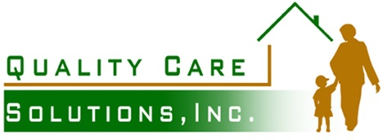

Quality Care Solutions Inc. is a holistic approach to in-home and community based mental health and developmental disable services. The mission of the agency is to empower, support, motivate, and encourage individuals and families coping with mental illnesses by building on the family’s strengths. Professional, and compassionate workers partner with the family to resolve
conflict and become a catalyst for positive change.

